**Introduction to AKS Private Clusters**

AKS is the Kubernetes service oﬀering from Azure. It allows you to manage the lifecycle of Kubernetes clusters at scale. By default, an AKS cluster uses a public IP address for the control plane. However, using a public IP address will expose the control traﬃc in your cluster to the Internet.

If you are concerned about the security threats of exposing control traﬃc to the Internet, you can create an AKS cluster with a private control plane IP address. However, the absence of a public IP address prevents you from directly connecting to a private AKS cluster from your computer.

**Creating an AKS Private Cluster**

Let’s create an AKS private cluster via Azure portal.

**Step-1**

Log in to the Azure portal and click on ‘Create a resource’.

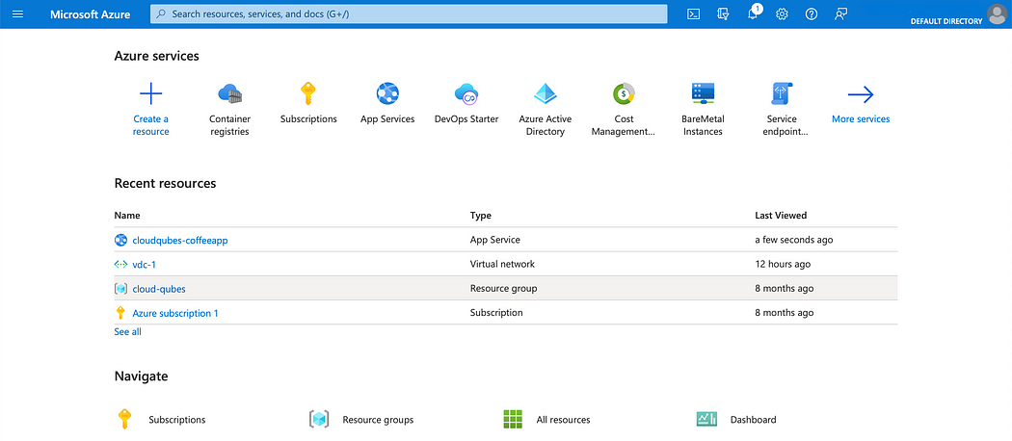

**Step-2**

Type ‘kubernetes’ in the search bar and click on ‘Kubernetes Service’

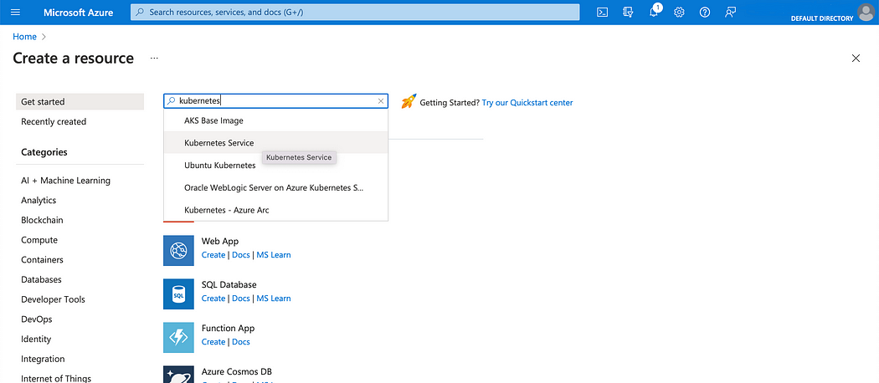

**Step-3**

Click on the ‘Create’ button.

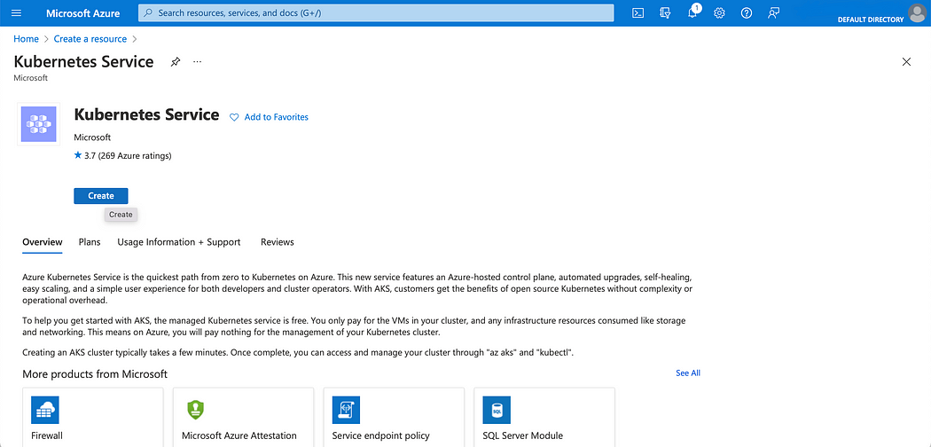

**Step-4**

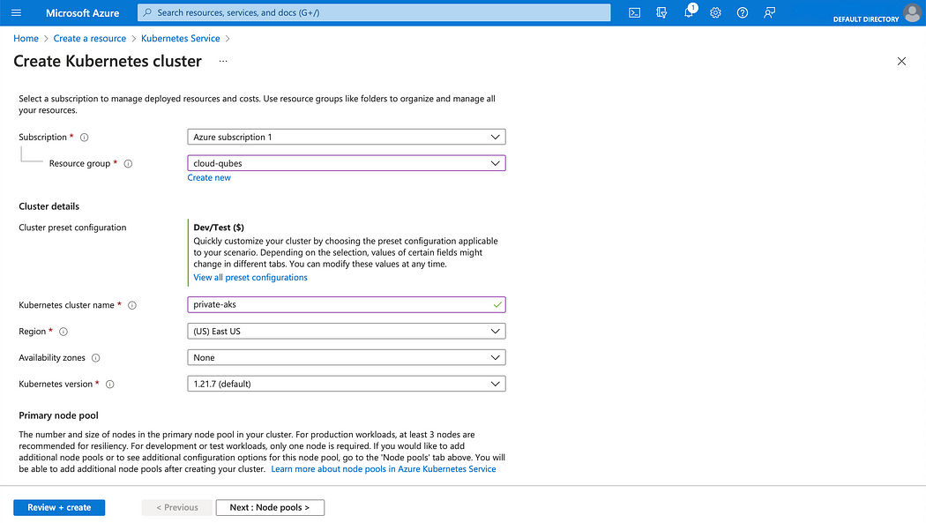

Azure portal guides you through a set of steps for creating the cluster. The mandatory parameters ‘Subscription’ and ‘Resource Group’ are used for billing purposes. If you do not have already created them, please create them by clicking on ‘Create new’.

AKS oﬀers several preset configurations for Kubernetes clusters. Click on ‘View all preset configurations’ and select your preferred configuration. If you want to try out AKS, ‘Dev/ Test’ would be quite enough.

The other mandatory parameter at this step is the ‘Kubernetes cluster name’. Leave the defaults for the rest of the parameters and click the ‘Next’ button at the bottom of the screen.

**Step-5**

In this screen, you can add ‘Node pools’. A node pool is a set Azure VMs with the same configurations. You can add multiple node pools to an AKS cluster depending on the types of workloads you want to run.

Let’s create this cluster with the default node pool that comes with just 3 nodes.

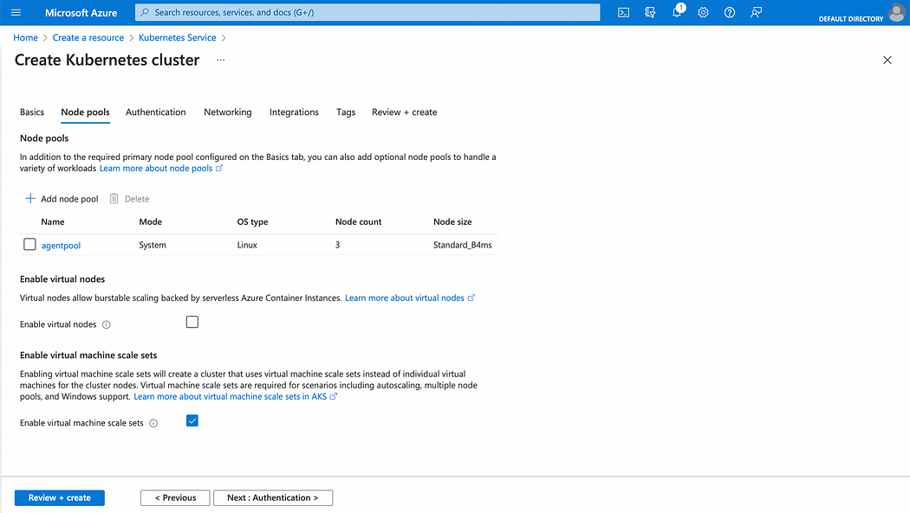

**Step-6**

Leave the default parameters in the ‘Authentication’ screen and click on ‘Next’

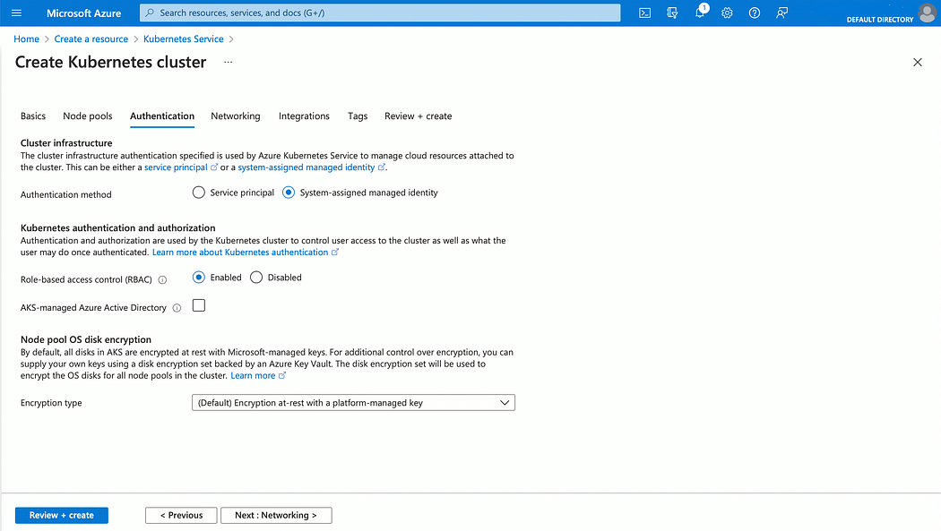

**Step-7**

In the ‘Networking’ screen select ‘Azure CNI’ as the networking configuration. Azure will be creating a new virtual network and a subnet to accommodate this AKS cluster. Note the name of the virtual network, as we would need it later when launching a VM.

Also, check the ‘Enable private cluster’ check box. This is the key parameter for a private AKS cluster.

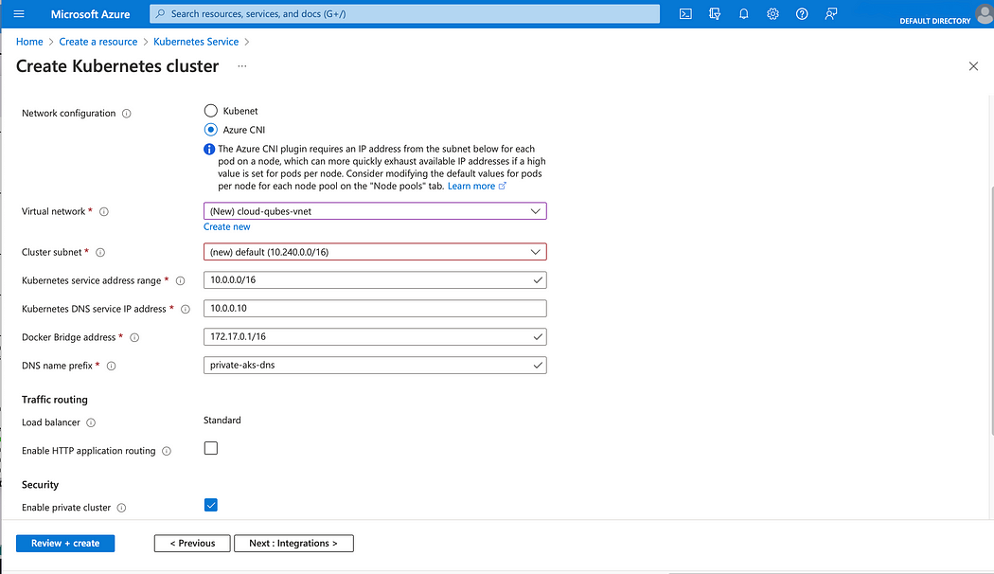

**Step-8**

Leave the default parameters in the ‘Integrations’ and ‘Tags’ screen each and click on ‘Next’.

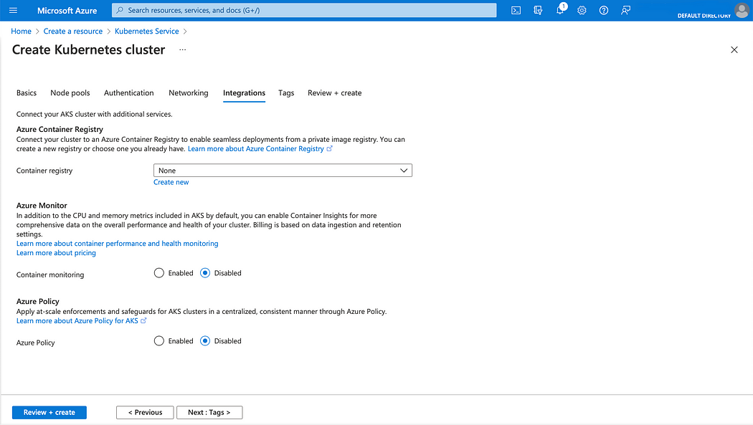

**Step-9**

In the ‘Review and Create’ screen, you will see a ‘Validation passed’ checkbox if all your values are correct. If not you may need to go back and correct the problematic parameters. After everything is fixed, click on the ‘Create’ button at the bottom of the screen.

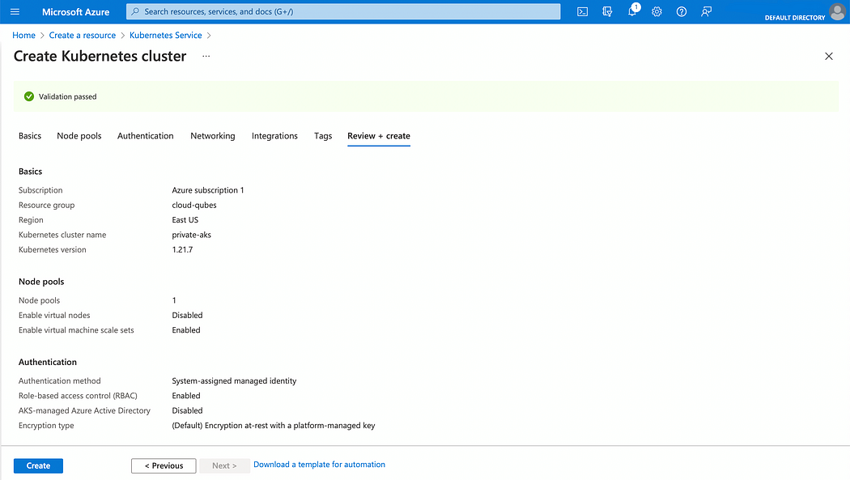

Azure will take several minutes to create the Kubernetes cluster.

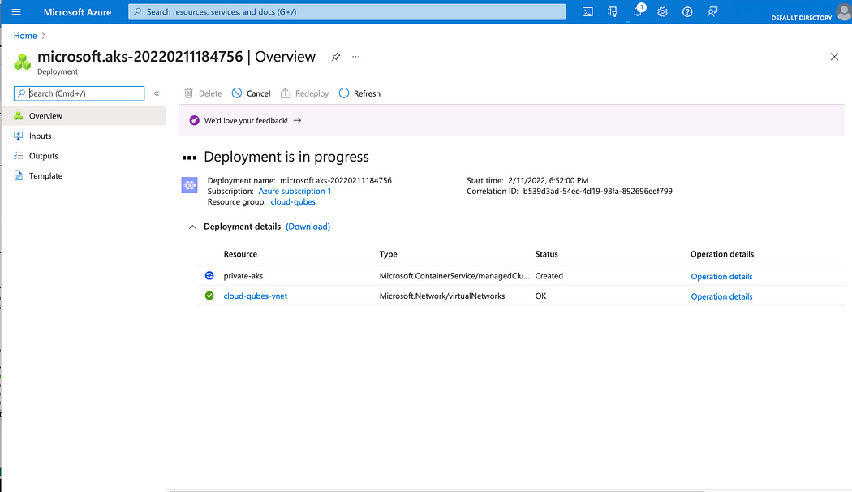

Once, the Kubernetes cluster is created, you will get the message ‘Your deployment is complete’.